Mobile Health Applications to Increase Hypertension Health Literacy of Jamaican Adults

Amde Beaumont (1507124)

BSc inComputing*,* Major in Computer Science

Tahjae Campbell (1507135)

BSc inComputing*,* Major in Computer Science

Sean Gayle (1507138)

BSc in Computing, Major in Computer Science

Matthew Reid (1507120)

BSc in Computing, Major in Information Technology, Minor in Networking

Faculty of Engineering and Computing, University of Technology, Jamaica

Project Supervisor: S. Muir

**Table of Contents**

Executive Summary 1

Chapter 1: Introduction 3

Background 3

Problem Statement 5

Purpose of the Study 5

Significance of the Study 6

Research Questions 6

Definition of Terms 6

Chapter 2: Literature Review 8

Introduction 8

Prevalence in Jamaica 9

Health Literacy 10

mHealth Technology 12

Computer mHealth Applications 12

Computer mHealth Applications for Hypertension 13

Conclusion 15

Chapter 3: Methodology 16

Research Design 16

Population 16

Sampling 17

Instrumentation 17

Procedure and Timeframe 18

Analysis Plan 18

Limitations 18

Chapter 4: Results 19

Introduction 19

Hypertension Health Literacy by Participant Demographics 21

Technology Acceptance of mHealth among Urban Jamaican Adults 25

Effectiveness of mHealth Applications in Improving the Health of Urban Jamaicans 28

Discussion 30

Chapter 5: Conclusion and Recommendations 31

Recommendations 31

Conclusion 33

References 35

Appendices 40

Questionnaire 40

Quiz 47

Health Care Professional Responses for Mobile Hypertension Application 50

Response 1 50

Response 2 53

Response 3 56

Mobile Application Screenshots 58

Main Menu 58

Your BP 59

BP Recommendations 61

Lessons 62

BP Chart 65

# Executive Summary

It is no secret that hypertension is a prevalent medical condition in Jamaica. Research has shown that an estimated 1 in 4 Jamaicans suffers from the condition. Many Jamaicans have family members or friends who are hypertensive. Hypertension, commonly called high blood pressure, can go undetected for years and as such has been infamously named the silent killer. Hypertension sadly often allows an individual to be susceptible to other ailments such as heart disease, heart failures, kidney problems, vision problems and many more.

But why do so many Jamaicans fall prey to the disease even though it is so common? Simple. Lack of hypertension health literacy. Health literacy can be defined as having sufficient knowledge about a medical issue so you can make informed decisions to keep yourself healthy. Many Jamaicans know of hypertension, but many do not know enough about hypertension to keep themselves healthy. In essence, because of a lack of hypertension health literacy, many Jamaicans become susceptible to a medical condition that can easily be thwarted by simply applying the correct preventative measures.

However, many Jamaicans are not presented with knowledge about hypertension more readily. Many more don’t have access to the information or are not inclined to seek out this knowledge because either they believe they are not at risk and/or don’t think about hypertension at all. Sighting these factors, a solution has been highlighted to bringing hypertension-related information to Jamaicans. This medium is through mHealth and more specifically mobile health apps. Mobile health applications are a budding field in medical technology and provide an avenue to reach individuals in the growing technological world. This study aims to explore the effectiveness of mobile health applications in increasing hypertension health literacy of Jamaicans, with the belief it could lessen the prevalence of hypertension amongst Jamaican adults.

Using a one-group pretest-posttest design, 20-25 adults were selected for the research study. These individuals were given a hypertension-based questionnaire to gather data on demography, hypertension and technology acceptance. They were given a newly developed hypertension mobile app aimed at increasing their hypertension literacy. Finally, these individuals were given a quiz containing the same material from the initial questionnaire to note changes/improvements in their knowledge of hypertension since using the mHealth app provided.

The results were analyzed and a marginal increase in hypertension literacy levels was found. Results showed 12.5% higher health literacy scores from the older participants. An initial 95.5% of participants were willing to use a hypertension app and 85% found the newly developed app useful. Overall, the survey recorded a 13% increase in hypertension literacy levels. This research suggests that mobile health applications can be useful to educate as well as help Jamaicans manage and/or control hypertension. In addition to this, the research also suggests that Jamaicans are very much willing to use a hypertension-focused mobile app.

Nonetheless, several factors affected our research process, most notably the COVID-19 pandemic which reduced our population sample size and resulted in a convenience sample approach. Another limitation was having our application only designed for Android devices. This move skewed our research criteria to some extent. Application feedback suggests further testing be done with the mobile health applications concerning content, design and interactiveness to encourage continued use by users. It is recommended that much more research, time and vastly more application testing be implemented on future mobile health applications to provide the best possible service and care to Jamaican citizens.

# Chapter 1: Introduction

## Background

According to the World Health Organization (WHO), an estimated 1.13 billion people worldwide suffer from hypertension. Often referred to as “high blood pressure”, hypertension is a serious medical condition that significantly increases the risk of heart, brain, kidney and other diseases (World Health Organization, 2019). WHO (2019) marks hypertension as a major cause of premature deaths as it is estimated to cause 7.5 million deaths contributing to 12.8% of all deaths worldwide. The prevalence of hypertension in the Caribbean is high, affecting 21% of adults in Barbados and Trinidad and Tobago, 25% in Jamaica, and 35–38% in St Kitts, British Virgin Islands and Grenada (Figueroa, Harris, Duncan & Tulloch-Reid, 2017).

Hypertension rates have been shown to decline through the intervention of health literacy. By utilizing provided health-related resources, individuals can make informed decisions to take charge of their health (Brabers, Jany J. D. Rademakers, Groenewegen, Dijk, & Jong, 2017). Health literacy has proven to be beneficial to overall patient health by increasing patient knowledge and satisfaction, provide better peace of mind as well as offer better compliance to treatment (Brabers et al., 2017). On the other hand, low or non-existent levels of health literacy have been shown to coincide with poor health outcomes, negative behaviour and higher health costs (Aoki & Inoue, 2017). Health literacy offers an approach to maximize individuals’ health knowledge, understanding of health-related issues and how to respond to those issues (Heijmans & Rademakers, 2018).

With the implementation of mHealth technology into the healthcare industry, an effective method was born to deliver healthcare services such as patient management, education and diagnosis support (Gagnon, Ngangue, Payne-Gagnon, & Desmartis, 2015). mHealth applications are rapidly transforming the way health services and information are accessed, delivered and managed (Han & Lee, 2018). An estimated 325,000 health, fitness, and medical mobile applications are available (Donevant, Estrada, Culley, Habing & Adams, 2018). Considering its ubiquity, mHealth technology provides a prospective way to promote health literacy and patient self-management (Bengtsson, Kjellgren, Hallberg, Lindwall, & Taft, 2015).

Concerning hypertension, several studies have been conducted on the use of mobile technologies in aid of keeping the condition under control. Patients using mHealth devices have shown improvements in blood pressure reduction as compared to those who do not (Bhavnani, Narula, & Sengupta, 2016). Moreover, Benggtsson et al. (2015) in a paper titled *“Improved Blood Pressure Control Using an Interactive Mobile Phone Support System”*, the self-monitoring of hypertension proved most successful when coupled with education and counselling.

A study of the influence of self-monitoring mHealth applications showed that hypertensive individuals eager to change health behaviours were excellent candidates and improved with the added aid (Kim, Wineinger, & Steinhubl, 2016). A randomized clinical trial with the use of home blood pressure telemonitoring alongside a self-care mHealth application yielded results of mean systolic blood pressure decreasing by more than 9 mm Hg (Logan, 2013). Improvements in blood pressure have also been demonstrated with the use of SMS interactive monitoring that sets reminders for patients, collects data and schedules visits (Marcolino, et al., 2018).

## Problem Statement

Hypertension is one of the most pervasive medical conditions globally and it affects approximately 1 in 4 Jamaicans (WHO 2019; Figueroa et al., 2017). One of the many reasons hypertension is so prevalent is due to a lack of health literacy. Health literacy is a social factor that involves the use of health-related education and services to make critical health decisions (Machado, Lima, Cavalcante, Araújo, & Vieira, 2014). Health literacy has proven to be beneficial to overall patient health, patient knowledge and satisfaction (Brabers et al., 2017).

Furthermore, mHealth tools, devices and applications have been shown to be successful in improving patients’ overall health (Han & Lee, 2018). Research has shown substantial evidence that mHealth applications have reduced blood pressure in patients especially when paired with health education and counselling (Bhavnani, Narula, & Sengupta, 2016; Benggtsson et al., 2015). mHealth applications are accessible, available and offer an efficient means to counter hypertension by offering much-needed healthcare services as well as relevant health information to users (Ganon, et al.; Han & Lee, 2018); all in the palm of the hand. However, despite promising results involving the implementation of mHealth applications against hypertension, more clinical trials and real-world applications are needed (Parati, Torlasco, Omboni, & Pellegrini, 2017).

## Purpose of the Study

The purpose of this study is to explore the effectiveness of health literacy through the use of a mHealth application to counter hypertension. We will examine how mHealth applications can incorporate the use of health literacy to improve the self-managing behaviours of individuals by fostering informed thinking and decision making.

## Significance of the Study

It is anticipated that through the use of mHealth applications, hypertension rates may be successfully reduced by introducing standardized health literacy in Jamaica. We expect an overall better health status for Jamaicans. In addition to this, it is hoped that the Jamaican health sector can exploit the use of mHealth technology to improve Jamaica’s healthcare system.

## Research Questions

1. What is the hypertension health literacy levels of urban Jamaican adults (by age, sex and education level)?
2. What is the technology acceptance of mHealth among urban Jamaican adults?
3. How effective can mHealth applications be in improving the hypertension health literacy of urban Jamaican adults?

**Delimitations**

* Each participant who participates in the survey is known by a researcher.
* Survey is conducted within a set timeframe.

## Definition of Terms

* **Hypertension** - Known as high blood pressure, is the atypical high in arterial blood pressure throughout the body.
* **Systolic blood pressure** - The pressure at which the heart beats – while the heart muscle is contracting (squeezing) and pumping oxygen-rich blood into the blood vessels.
* **Diastolic blood pressure** - The pressure on the blood vessels when the heart muscle relaxes. The diastolic pressure is always lower than the systolic pressure.
* **mm Hg** - Millimetres of mercury. Unit of measure for pressure.
* **mHealth** - the use of mobile and wireless communication technologies to improve healthcare delivery, outcomes, and research**.**
* **Health Literacy** - Health Literacy has been defined as the cognitive and social skills which determine the motivation and ability of individuals to gain access to, understand and use information in ways which promote and maintain good health.

# Chapter 2: Literature Review

## Introduction

Hypertension is one of the most pervasive medical conditions in the world and is responsible for millions of deaths annually. It can be described as abnormally high arterial blood pressure, thus the reason for its more common name “high blood pressure” (Singh, Shankar, & Singh, 2017). Often dubbed the “silent killer”, hypertension tends to remain unseen during its early stages unless detected by measurements or as a result of severe ailment (Singh et al., 2017). However, adjustments in lifestyle can effectively prevent or tame the condition (Rajati et al., 2019). The contributors to higher blood pressure are being overweight or obese, excessive salt intake, alcoholism, poor dieting and not enough physical activity (Carey, Muntner, Bosworth, & Whelton, 2018). These factors are not only linked to higher than normal blood pressure but allow hypertension to be the main risk factor for other medical issues such as coronary heart disease and failure, chronic kidney disease, stroke, and cerebrovascular disease among many others (Singh et al., 2017; Carey et al., 2018).

Health literacy is a means by which hypertension can be targeted. With greater levels of health-focused education for hypertension, it can be managed and/or prevented. mHealth technology has proved most effective in combatting well-known diseases. Hence, the use of mHealth applications could prove a feasible medium to administer health literacy. mHealth applications are cost-effective, accessible and available to individuals who need it. The literature confirms the issue of the prevalence of hypertension in Jamaica, health illiteracy as a huge contributing factor, and how with the use of mHealth applications, hypertension can be prevented, managed and/or controlled.

## Prevalence in Jamaica

All Jamaicans at some point another have heard of hypertension or by its more common name ‘high blood pressure’. It is estimated that at least 1 in 4 Jamaicans are hypertensive (Figueroa, Harris, Duncan & Tulloch-Reid, 2017).

There have been multiple studies and surveys captured over the years which highlight statistics about this medical condition that has plagued the island. One such body is The Jamaica Health and Lifestyle Survey which is tasked with conducting and analyzing various medical surveys on the island. Based on a study conducted by the Jamaica Health and Lifestyle Survey in 2007-2008, a parallel study was published by Trevor et al. in 2018. This study aimed to give insight into how prevalent hypertension was amongst you adults. From the study, 898 young adults between ages 18 and 20 were tested for various medical attributes such as blood pressure, glucose levels as well as other anthropometric measurements. From the blood pressure test that was carried out on the sample approximately 21% tested for hypertension (Trevor et al., 2018). Statistically, in comparison to other studies, this number could’ve been much higher if a wider range in age were included in the survey.

Another example is a study of a blood pressure campaign carried out by the International Society of Hypertension. This campaign took place from May to June of 2017 (Nwokocha, et al., 2019). The participant sample comprised of 566 individuals who volunteered to be a part of the study. These volunteers hailed from 5 different eastern parishes and included participants from various factions such as schools, churches, and civil institutions as well as accounting for individuals from both rural and urban areas. According to Nwokocha, et al. (2019), of the 566 participants tested for hypertension, 267 were classed as hypertensive which is 43.7%. Of those who tested positive 35.6% were completely unaware they were hypertensive.

Additionally, an alternative study was carried out by Lock Haven University in the United States. In this study, a basic health clinic was set up in a rural community in Manchester, Jamaica (Hershey & Way, 2017). This clinic collected medical data such as BMI and blood pressure readings along with the medical history of the 95 individuals. Their results concluded that 42% of the individuals interviewed and tested were hypertensive.

Many more hypertension surveys and initiatives have been carried out over the years. All the results of these studies point to the obvious fact that the Jamaican population is struggling with dealing with the medical condition**.** Given the facts presented it is quite clear that this issue of hypertension needs to be taken into serious consideration and addressed urgently.

## Health Literacy

As described by Machado, Lima, Cavalcante, Araújo, & Vieira (2014), health literacy is defined as “the capacity to obtain, process and understand basic health information and services required to make appropriate health decisions”. Higher levels of health literacy are equivalent to better health status such that it allows individuals to adopt healthier behaviours and utilize critical thinking to gather and seek out relevant health information (Jacobs, Lou, Ownby, & Caballero, 2014; Chan & Kisa, 2019). Health literacy can be regarded as a social factor that influences or has a positive impact on overall health (Loan, et al., 2018). Loan, et al., (2018) states that this social factor is geared towards effectively focusing and promoting greater control over health through education and an individual’s internal motivation to keep healthy. On the contrary, low health literacy has proven to be synonymous with poorer health status, non-adherence to medication and increased hospitalization rates (Jacobs, Lou, Ownby, & Caballero, 2014). Jacobs et al., (2014) in a published systematic review, stated that a lack of health literacy influenced the increased use of health services which led to higher health costs.**Health Literacy and Hypertension**

With hypertension estimated to affect approximately 1.56 billion people by the year 2025, an intervention needs to be put in place to lessen its occurrence (Rajati, et al., 2019). Many interventions have been approached over the years to utilize health literacy to combat common diseases such as asthma, diabetes and heart failure (Halladay et al., 2017). However, very few studies have been conducted for the hypertensive community (Halladay, et al., 2017). Hypertension health literacy in response, is the capacity to obtain information on the condition, process and understand this basic health information and utilize services available to make appropriate health decisions.

Health literacy is an effective way to keep high blood pressure at bay while simultaneously self-managing the condition to ward off the likelihood of contracting other diseases caused by hypertension’s risk factors (cardiovascular disease, kidney disease, etc.) (Yilmazel & Çetinkaya, 2017). In a study carried out by Yilmazel and Çetinkaya (2017), substantial evidence points to the fact that increased health literacy levels indeed helped to manage hypertension. In a clinical trial conducted by Halladay et al., a multi-level approach was taken to infuse clinical staff and hypertensive patients with the principle of health literacy. The trial proved successful in reducing the average systolic blood pressure amongst the participant sample (Halladay, et al., 2017). The heavy incorporation of health-related information and “by the book” understanding and procedures made the trial even more successful than initially thought possible.

Improvements in hypertension health literacy have been shown to successfully aid in managing and controlling the condition. With a wider range of focus on the application of health literacy to not only incorporate the basics of reading and writing, more interactive approaches should also be taken to maximize patients’ potential (Heijmans & Rademakers, 2018). Nutbeam introduced an interactive approach that entailed the use of a more advanced form of health literacy focused on social skills coupled with active participation. Nutbeam suggests this approach provides health information and allows individuals to formulate informed decisions that allowed them to adapt to changing circumstances (Heijmans & Rademakers, 2018 cited Nutbeam 2000). Thus, a method must be designed to appropriately administer health-related information hypertensive as well as non-hypertensive patients alike.

## mHealth Technology

To define mHealth technology, it is the utilization of mobile technologies to realize health objectives (Blackwell, 2018). Some of these objectives comprise of but is not limited to, enhancing healthcare for underserved populations with limited access to traditional healthcare resources, fill the deficit for primary care physicians and variations in physicians’ practice behaviour, to decrease emergency department visits and lowering healthcare costs (Nelson, et al. 2016; Logan, 2013; Steinhubl, 2013). Health-related applications have great potential for good professional care practices in health promotion, which encourages users to become more aware and responsible in adopting healthy lifestyles (Delgado, et al. 2017). Considering this, mHealth technology provides a prospective way to promote self-management and provide useful tools for obtaining patient information and the monitoring of their well-being (Benggtsson et al., 2015).

## Computer mHealth Applications

mHealth applications are rapidly transforming the way health services and information are accessed, delivered and managed (Han, 2018). Their numbers have doubled since 2015 and are projected to be valued at US$102.85 billion by 2023 (IQVIA, 2017), with an estimated 325,000 health, fitness and medical mobile applications available (Donevant, Estrada, Culley, Habing & Adams, 2018).

## Computer mHealth Applications for Hypertension

With a growing number of smartphone users and an ever-increasing amount of mHealth applications, there is a ubiquitous method for monitoring hypertension (Kitt, Fox, Tucker, & Mcmanus, 2019). Patients using mHealth devices have shown improvements in blood pressure reduction as compared to those who do not, and as such, numerous blood pressure monitoring devices have been developed (Bhavnani, Narula, & Sengupta, 2016). Take, for example, an iOS application called Cardiogram, which was developed for wearable devices and programmed using deep learning technology. Cardiogram has shown moderate blood pressure reduction for its users by using deep learning algorithms to predict hypertensive state from heart rate input and steps per day count (Kitt, Fox, Tucker, & Mcmanus, 2019).

Likewise, Benggtsson et al. (2015) conducted a clinical trial over 8 weeks using a mobile phone-based self-management support system which incorporated blood pressure self-reports, pulse, lifestyle as well as symptoms, well-being, delivery reminders and encouragement. The daily use of the mHealth system significantly reduced the blood pressure levels of the patients. The system mostly benefited users with moderate to high blood pressure levels. However, optimal results were best seen when the system was used for only a short period. Nevertheless, this mobile support application was an effective tool and showed that a mobile support system may be a useful tool to assist with patients self-managing their hypertension (Benggtsson et al., 2015). To add, a study of the influence of mobile self-monitoring health applications showed that hypertensive individuals eager to change health behaviours were excellent candidates and improved with the added aid (Kim, Wineinger, & Steinhubl, 2016).

However, despite the growing popularity and widespread availability and accessibility, mHealth applications in general lack efficacy and very few are successful (Marcolino, et al., 2018; Alessa et al., 2019). Marcolino et al, (2018) summarized that even with positive results in blood pressure reduction as well as improved quality of life, there are not enough clinical trials and systematic reviews to apply mHealth applications on a wider scale. Marcolino et al, (2018) attribute this to sub-par quality in the methods used in published systematic reviews. Promising results from mHealth applications are evident, however, larger and more long-term medical trials are required before these apps can be relied upon to deliver the best possible service (Parati, Torlasco, Omboni, & Pellegrini, 2017). Similarly, Logan (2013) pointed out that a major issue inhibiting the successful nature of mHealth application is lack of “rigorous usability testing”.

Research has shown most mHealth applications lack a theoretical foundation (Alessa et al., 2019). Alessa et, al. (2019) defines the “*theory*” as the identification of patients’ behaviours and how this behaviour can be changed to improve health. Also, present mHealth applications lack privacy and the necessary security measures and as such pose a threat to users’ confidentiality. Most notably, most of these mHealth applications lack the involvement of health care professionals’ influence in the development process. Mckay et al. (2016) highlighted a lack of regulated health promotion as a factor affecting the successful integration of mHealth applications. With that said, collaboration is needed amongst health care professionals, application developers, policymakers and researchers to successfully enhance the process of delivering safe, secure and effective mHealth applications to improve overall health and promote individuals’ self-management (Zhao, Freeman, & Li, 2016).

## Conclusion

The literature reviewed gives much-needed insight on the scope of hypertension, health literacy and mHealth applications substantially impacting the structure of our proposed mHealth application. Most notably from the literature, it can be said that hypertension is a huge issue plaguing Jamaica. Nevertheless, though hypertension is so prominent, many Jamaicans are uneducated about the medical condition and this contributes to its growth. Research shows that health literacy focused on hypertension has proven effective in fighting against the condition. With increased health literacy, individuals can process and understand basic health information on hypertension and utilize services available to make appropriate health decisions.

The literature has highlighted mHealth technology, specifically mHealth applications, as an avenue to execute health literacy. MHealth applications, across several studies, have been shown to reduce blood pressure levels. Also, mHealth applications provide a prospective way for patients to monitor their health and self-manage themselves based on informed decision making. However, the literature has also shown that most mHealth applications are ineffective in providing the best possible care for hypertension. Many of these applications are developed lacking the collaboration of application developers, policymakers, health care professionals and proper research to make the applications more accurate, meaningful and deliver a wider array of care.

# Chapter 3: Methodology

## Research Design

A one-group pretest-posttest design was used for this survey. A single group was initially tested for a set of data, then introduced to an intervention and finally tested again to determine change or difference between initial (pre) and second (post) data. The study aimed to determine how effective a mHealth application would be at improving hypertension health literacy in users and explore the impact the application would have in promoting self-managing behaviours.

The experiment was tested on a group of individuals selected based on convenience and availability due to the COVID-19 pandemic. The group was surveyed with a questionnaire, quiz and a newly developed hypertension mobile application. The questionnaire was issued initially to determine demographics, ascertain familiarity with hypertension and it contained marked hypertension literacy questions. A UTAUT2 model was implemented to determine individuals’ technology acceptance. Results that were collected from the pre-test survey (questionnaire) were used to establish a baseline for demographics and hypertension literacy as well as determine how comfortable these individuals would be with using a hypertension-focused mobile application. These individuals were then given the developed mobile application to use for a set amount of time. After the set time elapsed, the post-test survey (quiz) was issued containing the same marked hypertension literacy questions posed in the earlier questionnaire. The quiz also contained application feedback. The results on hypertension health literacy from both the questionnaire and quiz were tabulated and analyzed to find a change in overall hypertension knowledge.

## Population

The target population for this research were Jamaican adults across various parishes. Initially, the UTECH Medical Center and the Papine, St. Andrew corporate area were target areas for our survey. However, considering the COVID-19 pandemic, the target population was limited to comply with social distancing rules.

## Sampling

The survey sample consisted of 20-25 individuals from the sample population using convenience sampling. Participants were selected based on availability, accessibility and willingness to be a part of the survey. They had the option to opt-out of the survey if they feel the need to.

## Instrumentation

The survey was administered using a questionnaire and a quiz. The questionnaire consisted of a total of 33 questions and quiz 20. The UTAUT approach to test the technological acceptance of the user was modelled based on the approach used by Pontiggia & Virili in *Network Effects in Technology Acceptance* (2009). Questions in the survey to assess health literacy were based on an approach used in “*Health Literacy in Rural Areas of China: Hypertension Knowledge Survey*” by Xia Li. The age criteria for this survey was 18 years and older. The questions were closed-ended and open-ended to collect demographic data, determine participants’ hypertension health literacy and technology acceptance towards mHealth applications.

Information presented in the mobile application was obtained from three licensed health care professionals. These professionals were interviewed for a maximum of 20 minutes each to ascertain information on hypertension literacy, recommendations for hypertensive patients by stage, their view on a mobile hypertension application and what should be included in that application. In addition to that, information from the World Health Organization (WHO) and the American Heart Association was also used.

## Procedure and Timeframe

Interviews with the health care professionals took place between June 20-23, 2020. The questionnaire was issued from June 15th and closed on June 23, 2020. The mobile app rolled out on June 25, 2020. Finally, the quiz was issued July 1, 2020 and closed July 3, 2020. In light of the COVID-19 pandemic, an online approach was used to administer the survey materials. The questionnaire and quiz were created and issued via Google Forms.

## Analysis Plan

The data collected from the tests will be analyzed using quantitative analysis. The participants initial score (questionnaire) will be compared with their final score (quiz) to determine change in hypertension literacy levels as well as record demographic data. Google Forms Analytics will be used for this comparison. Technology acceptance from the pre and post tests will be recorded and tabulated with Microsoft Excel. Results will be represented as pie charts and bar graphs for easy pictorial viewing.

## Limitations

The limitations that were faced by the researchers during the process of carrying out this study included:

* The mobile application was only designed for Android devices.
* The sample size was not enough for a survey of this nature.
* Participants did not understand the questions presented in the questionnaire and/or quiz.
* Participants did not complete the questionnaire.
* Some participants did not use the app provided.
* Participants completed the questionnaire and not complete the quiz.
* Participants were not able to install the mobile app on their device because of various reasons.

# Chapter 4: Results

## Introduction

The purpose of this study is to explore the effectiveness of a mobile health application in increasing the health literacy of an individual to counter hypertension. Using a sample size of 21 participants, a questionnaire was issued to target demographics, technology acceptance and to assess initial hypertension literacy. Participants then used the newly developed mobile application for 5 days and were then administered a quiz containing the exact marked questions on assessing health literacy found in the questionnaire. The results of the tests are as follows.

**User Demographic**

The experiment was performed with a sample size of 21 persons. Seven (7) participants were female and fourteen (14) were male (see Figure 1). The participants were chosen from varying age groups. Of the 21 participants, 9 persons were between the ages of 18-25, 3 persons between 26-35, 1 between 36-45, 4 between the age of 46-55, 3 between the ages of 56-65 and 1 person between the age of 66-75 (see figure 2). Most participants tested had tertiary education (19 persons) and only 2 persons had a Highschool Education. No participant had a primary education as their highest level of education (see Figure 3).

**Gender of Participants**

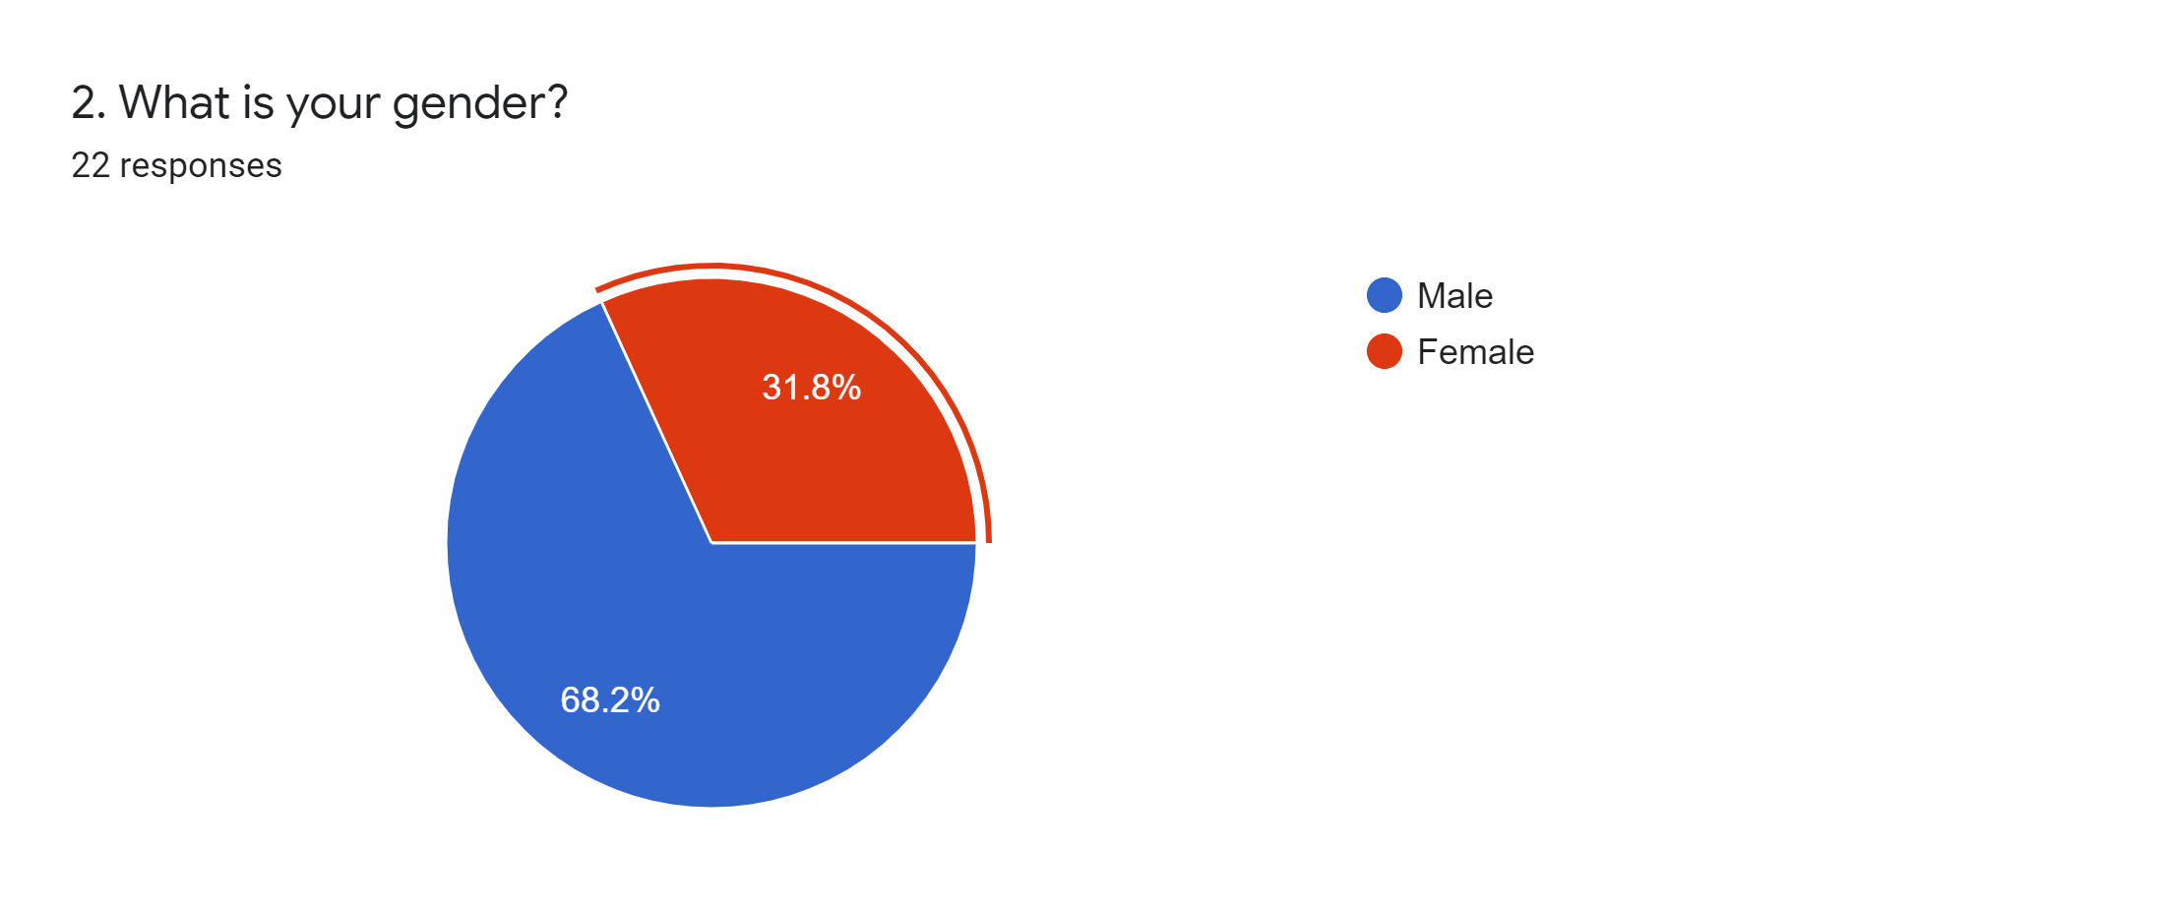

*Figure 1. Showing the gender demographic of participants*

**Age Distribution of Participants**

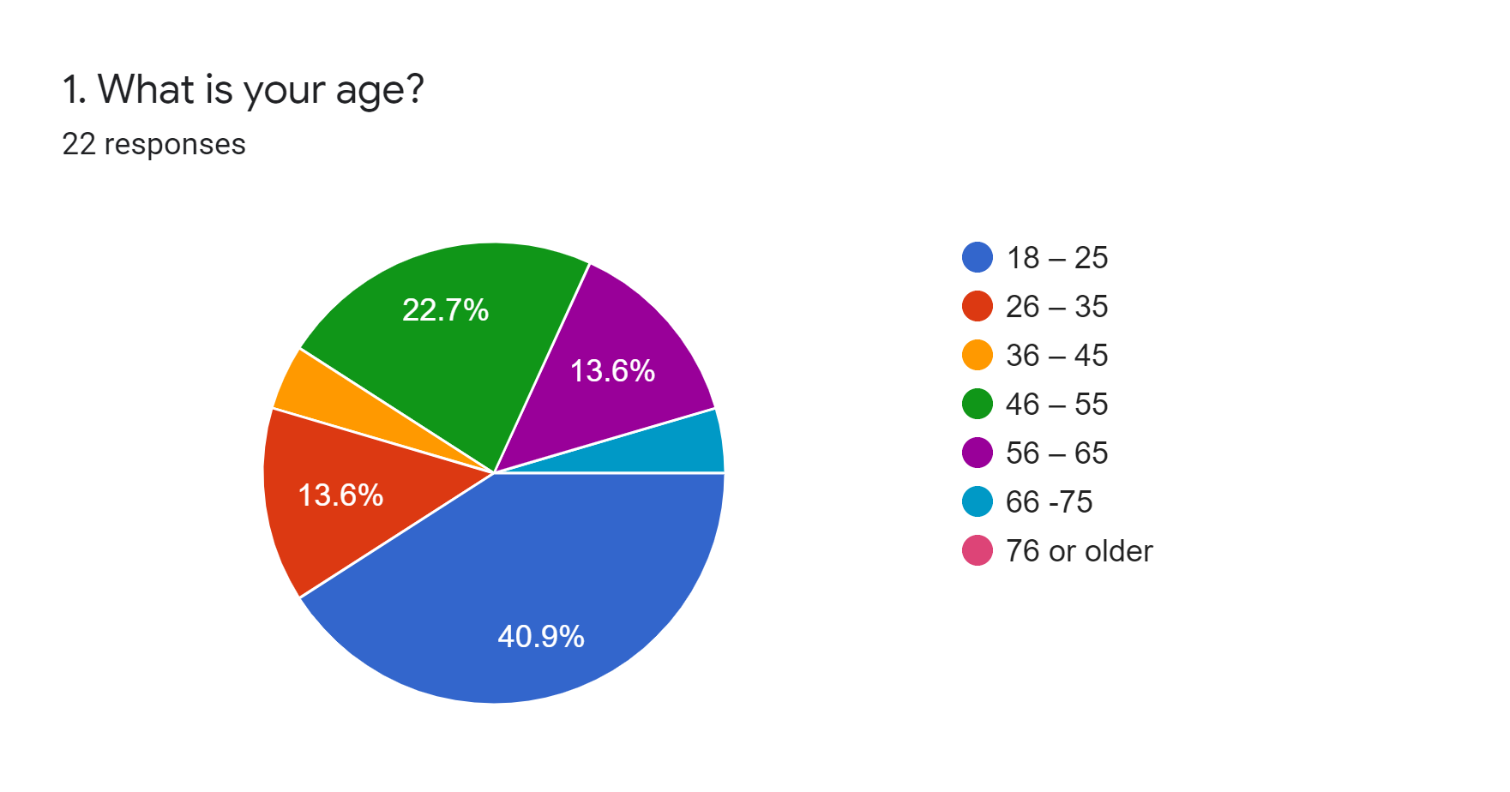

*Figure 2. Age demographic of participants*

**Education Level of test Participants**

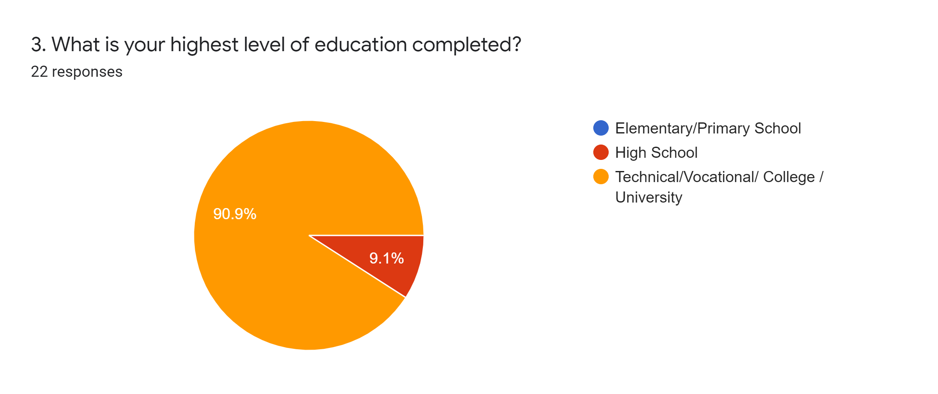

*Figure 3. Showing the Education level of all participants*

Most of the users tested did not have hypertension or were not sure they did. Figure 4 shown below gives a representation of the hypertensive status of all the participants. Eighteen (18) participants did not have hypertension or were not sure, 2 were diagnosed with hypertension for between 1 and 5 years and 1 person had hypertension for over 10 years.

**Hypertensive Status of Participants**

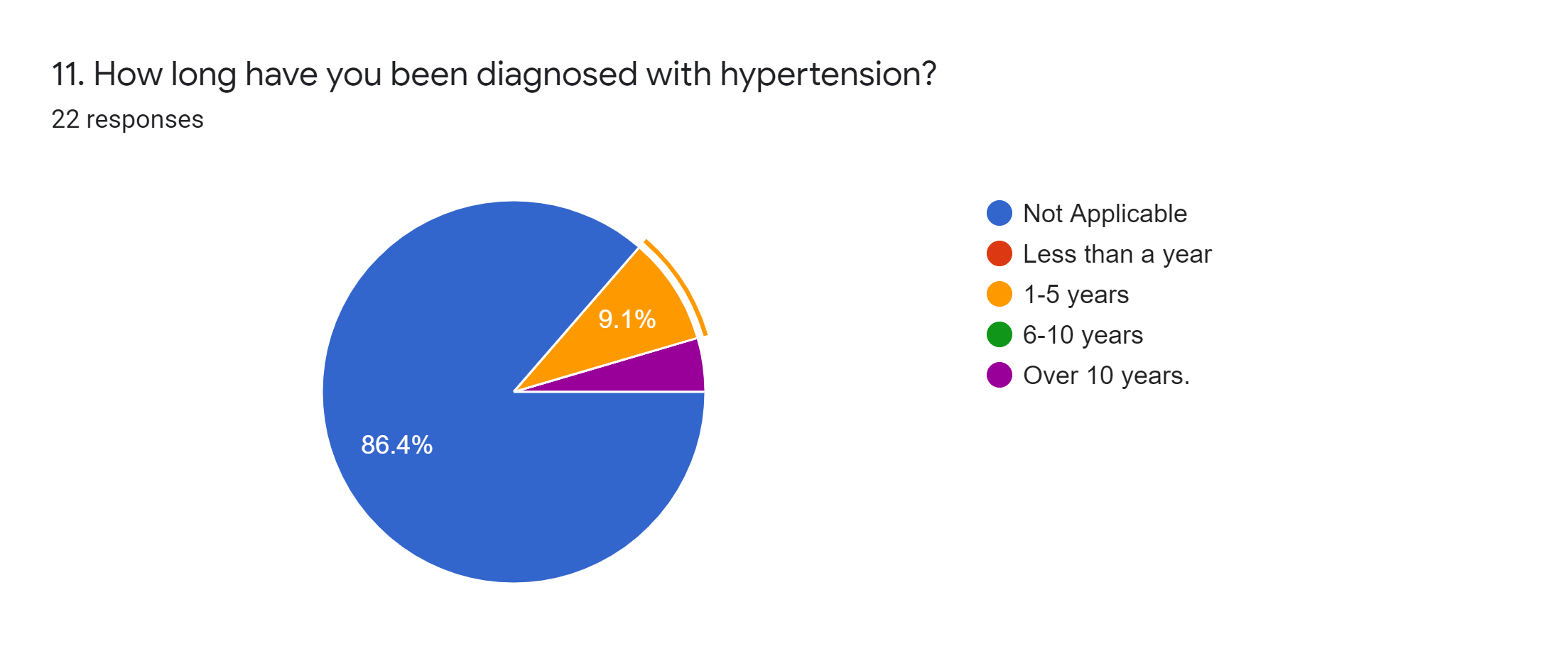

*Figure 4. Hypertensive Status of Participants*

## Hypertension Health Literacy by Participant Demographics

Figure 5 below shows the average initial health literacy score of the participants by their age group. The scores of the participants between the ages of 18-45 are in orange and the scores of those between the ages of 46-75 are in red. If we are to take an average of the scores between these age groups, the average score for the 18-45 group would be 7.6/10 and 8.8/10 those between the age of 46-75. This comparison can be seen in Figure 6. Notice the average health literacy score of persons over 46 is higher than those between 18-45 by 1.2 points or 15%.

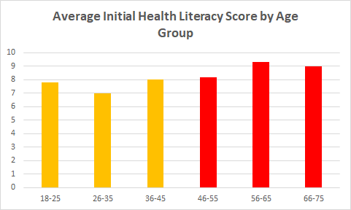

*Figure 5. Average Initial Health Literacy Score by Participant Age Group*

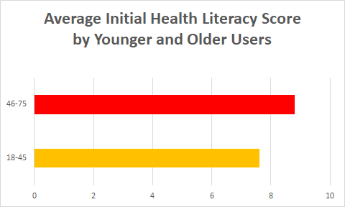

*Figure 6. Average Initial Health Literacy Score by Younger and Older users*

Figure 6 shows the average health literacy score of the participants by their gender. The average score for the females was 8/10 whilst the average score for the males was 8.1/10. As mentioned earlier in the Demographics section, there were only 7 female participants as compared to 14 males. Therefore, no comparison could be made between the health literacy of individuals by gender due to the small number of female respondents.

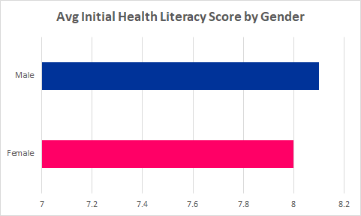

*Figure 7. Average Hypertension Literacy Score by Gender*

Figure 8 shows the average initial health literacy score by education level. As seen in the chart, persons with a high school education seem to have a higher health literacy score. However, this is not a reliable measure as only 2 of the 21 participants had only a high school level education. Hence no conclusion can be made given the limited responses education level diversity of the participants.

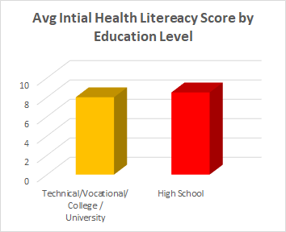

*Figure 8. Average User Hypertension Literacy Score Based on Education Level*

In figure 9 we can compare the score of users who have hypertension to the score of users who do not have hypertension. The average score of persons with hypertension was 9/10 and the average score for those without hypertension was 7.9/10. This result suggests that there is a link between a person’s hypertensive and hypertension literacy.

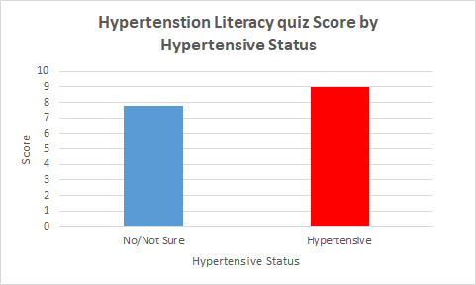

*Figure 9. Hypertension Literacy Score by Hypertensive status*

## Technology Acceptance of mHealth among Urban Jamaican Adults

Overall the technology acceptance of the test groups was high. Most participants would consider using a mobile health application to monitor their health. This can be seen in figure 10, 19 persons total, either agree or strongly agree to use a mobile app to monitor their health. Only 2 persons were neutral to using a mobile application and no one was against the idea of using mhealth applications.

**Would you use a Mobile Health Application to monitor your Health?**

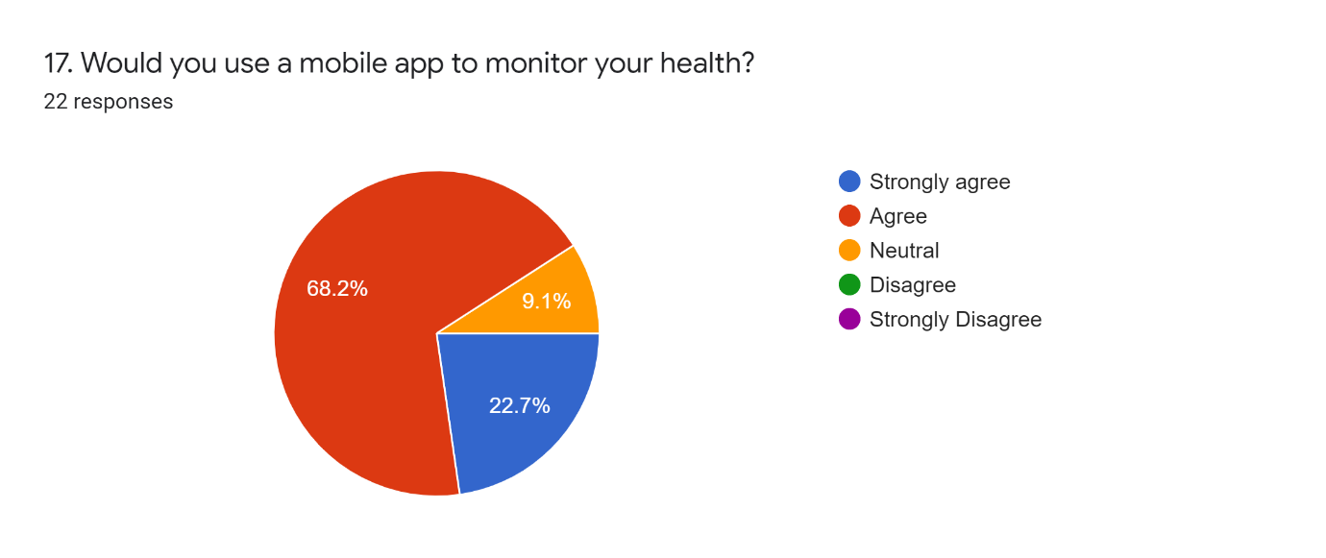

*Figure 10. Participants willing to use a mHealth Application*

To quantify the technological acceptance of all the participants, each response was given a score and all the scores compared. The maximum score a person could receive is 8 marks. Figure 11 shows the technology acceptance score received by all respondents. With an average technology acceptance score of 6.5, this shows a rather high technological acceptance level of all the participants.

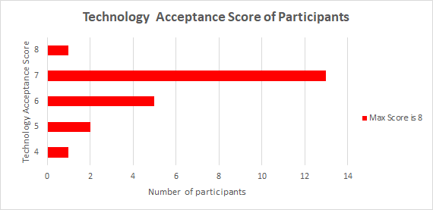

*Figure 11. Technology acceptance of participants*

Of the participants, 20 would either agree or strongly agree that a mobile application would be useful to teach them about hypertension, only one (1) person was uncertain about this (see Figure 12). It was a similar case for how the participants anticipated the ease of learning to use a mobile health app to teach them about hypertension. 20 persons either agree or strongly agree that a mobile application would be easy to use and 1 person was uncertain as can been seen in Figure 13.

**Do you think a Mobile app would be useful to teach you about hypertension?**

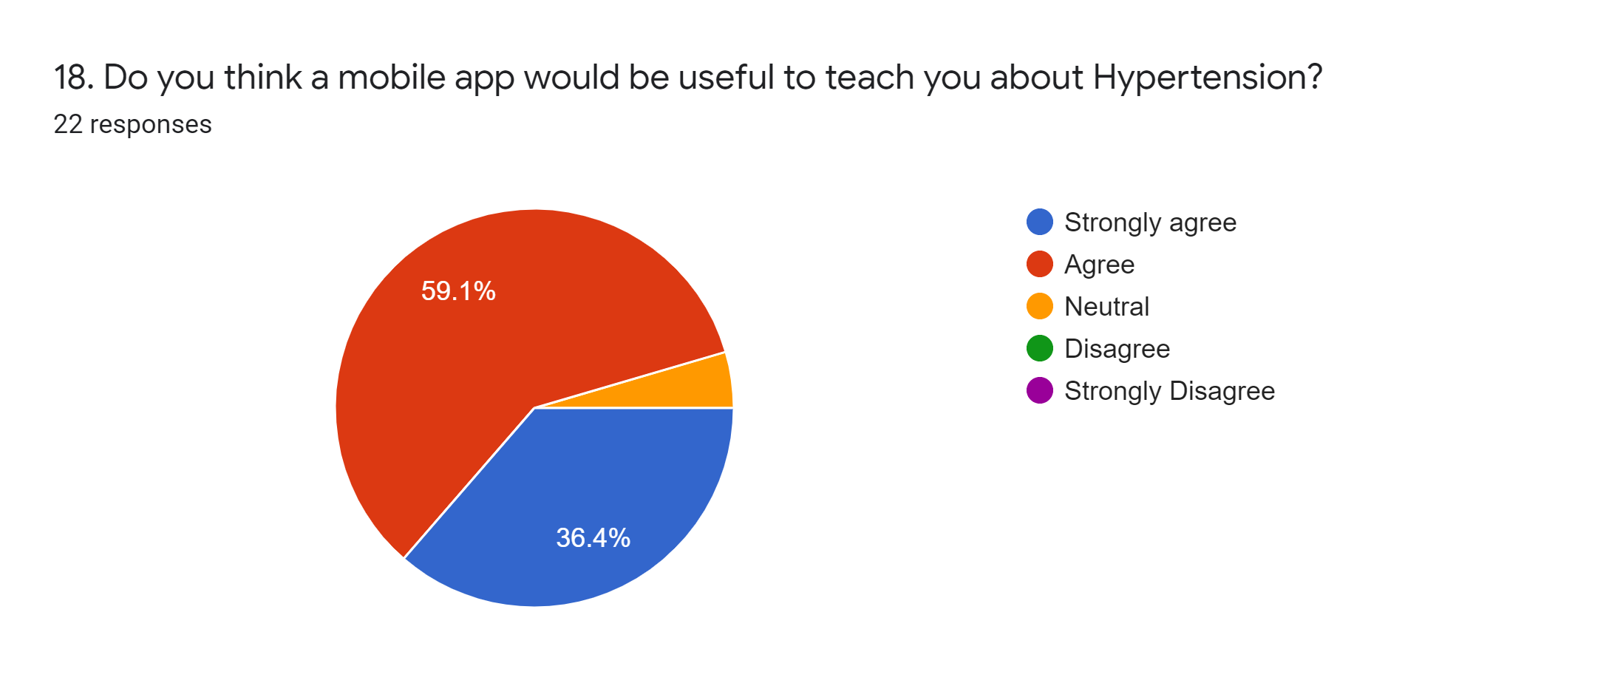

*Figure 12. Whether or not users think a mobile app can teach them about hypertension*

**Was the app easy to use?**

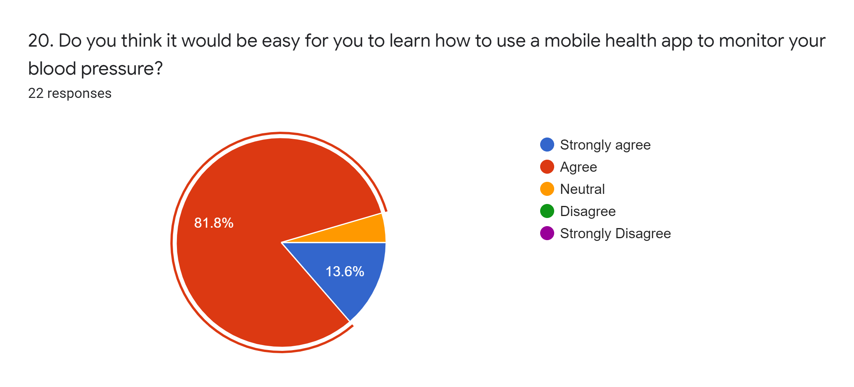

*Figure 13. How easy users found the app easy to use*

The users were given the app to use for 5 days and then given a quiz to gather their feedback and well as have them complete marked questions. 18 of the participants viewed the app as useful and 3 persons said it was not useful to them. This can be seen in Figure 14. In terms of the actual ease of use of the app, 11 persons viewed the app as easy to use, 3 found it of average difficulty and 4 found it to be difficult to use (see Figure 15).

**Was the app useful?**

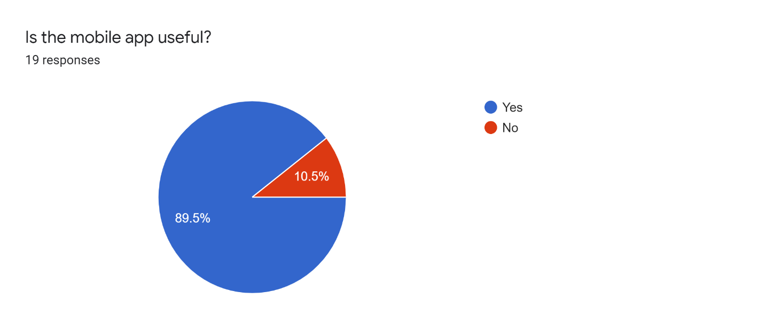

*Figure 14. Participants Who found the App Useful*

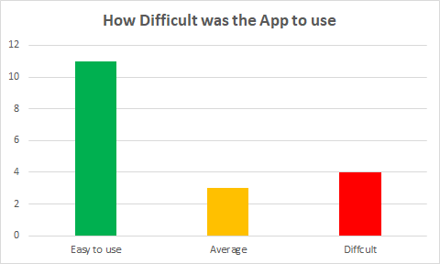

*Figure 15. Show the Difficulty of using the app*

## Effectiveness of mHealth Applications in Improving the Health of Urban Jamaicans

To get the best understanding of the results of the experiment, one must examine the results of each of the tests individually. In figure 14, we can see the results of the initial hypertension literacy test. The average health literacy test score is 8.05 out of 10 points. Also, notice the range of the scores. The lowest score was 5/10.

**Results of the Initial Hypertension Literacy Test**

*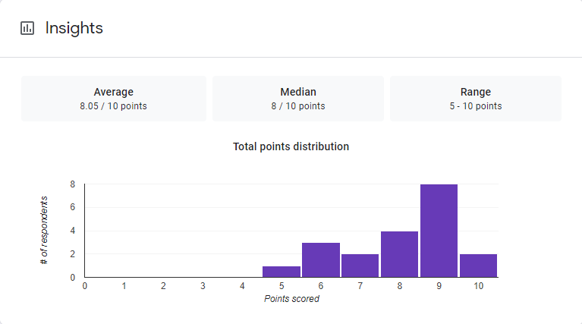Figure 16, Average initial Hypertension literacy Score*

Next are the results of the quiz administered after the app was given to the participants to test its effectiveness in increasing their hypertension literacy. These results are in figure 15 below. Notice that the average score has increased by 1 point to 9.05 which is an increase of 12%. Also, the range of the scores has tightened up to between 7 and 10 points, with the lowest score being 7/10.

**Results of the Second Hypertension Quiz**

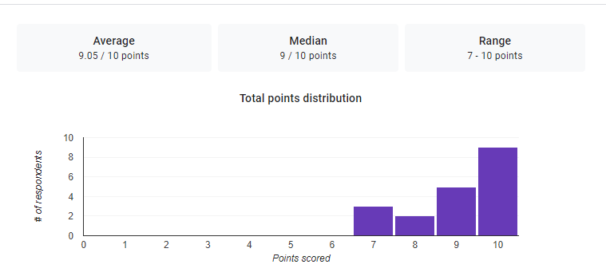

*Figure 17. Average Participants Hypertension Literacy Score after App Usage*

To summarize these results, the initial average literacy score was 8.05. After participants used the application that score was increased to 9.05, an increase of 12% (see Figure 16). The lowest score on the initial test was 5/10 and on the second test, the lowest score was 7/10. This is an increase of 2 points or 40%. Our results suggest that the hypertension mobile application has a marginally positive effect on the users' hypertension literacy.

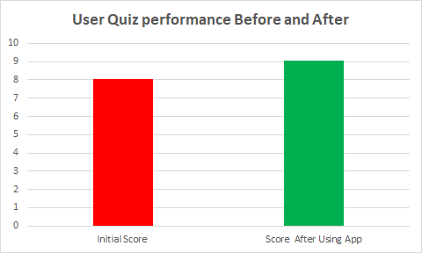

*Figure 18. Comparison between Initial Knowledge and Knowledge After App Usage*

## Discussion

Based on results from the survey and participant feedback for the mobile application, it is safe to say that a hypertension-focused mobile health application can indeed prove useful to combat the prevalence of hypertension in Jamaica. Feedback from the hypertension mobile application overall yielded positive results with approximately 89.5% of respondents finding it useful. Participant feedback, however, suggested improvements be made to the depth of the hypertension information and how that information is structured as well as including contacts for medical institutions in the case of an emergency. Participants also suggested that more work be done to make the application more interesting and interactive. Nevertheless, ‘*Lessons*’ was the most interesting feature of the application. Here, participants had 5 main topics about hypertension to learn from. The least used feature was ‘*Your BP*’ where participants had the opportunity to input a recent blood pressure reading they had taken. They were then presented with a tailored response based on their blood pressure reading. We suspect a lack of visual appeal is what led to this feature being the least used and as such more software tests and adjustments need to be made.

# Chapter 5: Conclusion and Recommendations

## Recommendations

Deploying the application on an app store will allow the app to be more accessible to the user. This will ensure that the application will be available to install without much technical knowledge.

Developing the application for multiple operating systems will ensure that the app is made available to as many users as possible. An effort to acquire a Mac computer or using a Virtual Machine will make it possible to build applications for both Android and iOS devices.

Ensuring that the test group is prepared for the experiment and understands what is required of them is imperative to the experiment's success. Provide teaching materials and tutorials for users to use to understand what they are expected to do to participate in the experiment. Having a dedicated team member to assist and handle queries can make an experiment run smoothly.

Regularly reminding and consulting with the participants is imperative. Many users will have jobs and other responsibilities and may forget to participate in the experiment. Provide timely reminders to ensure that persons don’t forget to engage in the experiment.

Have a separate test group to test the application and provide feedback. This will help the team iron out bugs and make the needed fixes to ensure that the main testing phase runs as smoothly and efficiently as possible.

Provide participants with a timetable of the test schedule. Make sure the user knows what they are expected to do and the timeframe that they must complete it. This ensures the completion of the experiment on time.

Gather more participants than you know you will want or need. Unplanned events can happen, and a participant may have to drop out of the experiment. Whatever the case, persons may not respond or be unavailable to participate. This will prevent an event where the sample size will be reduced to a point where the experiment will not be varied enough to return accurate results and conclusions.

**Summary**

This study was undertaken to combat the prevalence of hypertension in Jamaica by introducing hypertension health literacy by using mobile health applications. Our results have shown a positive correlation between mHealth application use and an increase in hypertension literacy.

The hypertension mobile health application was developed using Flutter, a popular open-source UI software development kit used to develop mobile applications for various platforms. The mobile application houses several features either to educate a user or in some form give recommendations to control their hypertensive state. All information presented in the mobile application was gathered from licensed health care professionals in addition to proper research from reputable international health bodies aiming to provide more meaningful care and health advice.

Firstly, a feature titled “Your BP” allows a user to input their most recent blood pressure reading (systolic & diastolic) and receive a tailored response based on that reading. The response will let the user know their current hypertensive state/stage. The second feature “BP Recommendations” continues from the first feature’s saved blood pressure reading and provides the user with simple recommendations for their hypertensive state. These may include recommendations such as basic dietary, exercise and checkup advice. Next, the feature “Lessons” contains information on hypertension broken down into five (5) categories. Each category has its section and the information is accompanied with images. Lastly, “BP Chart” provides the user with a visual representation of the readings for each stage of hypertension.

## Conclusion

This research paper sought to investigate the effectiveness of health literacy using a mHealth application to counter hypertension. In doing so a hypertension mobile application was created, issued and tested.

Pertaining to the first research question *“What is the hypertension health literacy levels of urban Jamaican adults (by age, sex and education level)?”,* our research has concluded that based on the factors of age, sex and gender, Jamaicans are knowledgeable about hypertension. In our pre-test (questionnaire) the lowest score achieved from a maximum of 10 was 5 or 50%. Our research did not yield any correlation amongst the listed demographics and as such no definitive answer can be given to state that these factors somehow are linked to hypertension literacy. This was due in fact to a very small sample size being used for our research.

Our second research question, *“What is the technology acceptance of mHealth among urban Jamaican adults?”*, yielded some positive results. In our pre-test survey (questionnaire) 90.9% of participants said they would use a mobile health application to monitor their health. Besides this, our results also pointed out that 89.5% of the participants found the mobile application to be useful. Our research gives conclusive evidence that Jamaicans are willing to accept a mobile approach to better their health literacy.

Lastly, for our final research question, *“How effective can mHealth applications be in improving the hypertension health literacy of urban Jamaican adults?”* we achieved a positive result though it was marginal. Initial surveys on assessing hypertension health literacy yielded an 8.05 (80.5%) success rate out of 10. After our hypertension mobile app usage, the success rate jumped to 9.01 (91%). This is a 13% increase over the initial survey alluding to the fact that the hypertension mobile health application was indeed successful and could be used in a wider capacity to benefit Jamaicans. Nevertheless, suggestions from participants highlighted flaws in our mobile application concerning content, features and design. These flaws must be taken into consideration to provide better quality mobile health applications for hypertension as well as other medical conditions that plague Jamaican citizens.

# References

Alessa, T., Hawley, M. S., Hock, E. S., & Witte, L. D. (2019). Smartphone Apps to Support Self-Management of Hypertension: Review and Content Analysis. *JMIR MHealth and UHealth*, *7*(5). doi: 10.2196/13645

Bengtsson, U., Kjellgren, K., Hallberg, I., Lindwall, M., & Taft, C. (2015). Improved Blood Pressure Control Using an Interactive Mobile Phone Support System. *The Journal of Clinical Hypertension*, *18*(2), 101–108. doi: 10.1111/jch.12682

Bhavnani, S. P., Narula, J., & Sengupta, P. P. (2016). Mobile technology and the digitization of healthcare. *European Heart Journal*, *37*(18), 1428–1438. doi: 10.1093/eurheartj/ehv770

Bourne, P., Morris, C., Charles, C. A. D., Eldermire-Shearer, D., Kerr-Campbell, M. D., & Crawford, T. V. (2010). Health literacy and health seeking behavior among older men in a middle-income nation. *Patient Related Outcome Measures*, 39. doi: 10.2147/prom.s11141

Brabers, A.E., Rademakers, J.J., Groenewegen, P.P., Dijk, L.V., & Jong, J.D. (2017). What role does health literacy play in patients' involvement in medical decision-making? *PloS one*.

Carey, R. M., Muntner, P., Bosworth, H. B., & Whelton, P. K. (2018). Reprint of: Prevention and control of hypertension: JACC Health Promotion Series. Journal of the American College of Cardiology, 72(23), 2996-3011.

Chan, R. W. Y., & Kisa, A. (2019). A Scoping Review of Health Literacy Measurement Tools in the Context of Cardiovascular Health. *Health Education & Behavior*, *46*(4), 677–688. doi: 10.1177/1090198119831754

Conger, S., Pratt, J. H., & Loch, K. D. (2013). Personal information privacy and emerging technologies. Information Systems Journal, 2013;23(5), 401–417.

Coverson, D. (2015). Health Literacy in Rural Jamaica: Visual Aides to Assist and Increase Medication Adherence. *MOJ Public Health*, *2*(5). doi: 10.15406/mojph.2015.02.00038

Delgado M, Miranda S, Rodrigues PF. An assessment of mobile applications classified in health and fitness. Acta Port Nutr. 2017; (8): 22-6. doi: 10.21011 / apn.2017.0805

Dinev, T., Albano, V., Xu, H., D'Atroi, A., & Hart, P. Individuals' attitudes towards electronic health records: A privacy calculus perspective. In A. Gupta, V. L. Patel, & R. A. Greenes (Eds.), Advances in Healthcare Informatics and Analytics, Annals of Information Systems 2016;19 (pp. 19–50). Switzerland: Springer publishing.

Donevant, S. B., Estrada, R. D., Culley, J. M., Habing, B., & Adams, S. A. (2018). Exploring app features with outcomes in mHealth studies involving chronic respiratory diseases, diabetes, and hypertension: a targeted exploration of the literature. *Journal of the American Medical Informatics Association*, *25*(10), 1407–1418. doi: 10.1093/jamia/ocy104

Dorans, K. S., Mills, K. T., Liu, Y., & He, J. (2018). Trends in Prevalence and Control of Hypertension According to the 2017 American College of Cardiology/American Heart Association (ACC/AHA) Guideline. *Journal of the American Heart Association*, *7*(11). doi: 10.1161/jaha.118.008888

Ferguson, T. S., Younger-Coleman, N. O., Tulloch-Reid, M. K., Bennett, N. R., Rousseau, A. E., Knight-Madden, J. M., ... & Wilks, R. J. (2018). Factors associated with elevated blood pressure or hypertension in Afro-Caribbean youth: a cross-sectional study. *PeerJ*, *6*, e4385.

Figueroa, J., Harris, M., Duncan, J., & Tulloch-Reid, M. (2017). Hypertension Control: The Caribbean Needs Intervention Studies to Learn How to Do Better. West Indian Medical Journal,

Fox S, Duggan M, Pew Research Center. Mobile Health 2012. Available at: <https://www.pewinternet.org/2012/11/08/mobile-health-2012/>.

Free C, Phillips G, Watson L, Galli L, Felix L, et al. (2013) The Effectiveness of Mobile-Health Technologies to Improve Health Care Service Delivery Processes: A Systematic Review and Meta-Analysis.

Gagnon, M.-P., Ngangue, P., Payne-Gagnon, J., & Desmartis, M. (2015). m-Health adoption by healthcare professionals: a systematic review. *Journal of the American Medical Informatics Association*, *23*(1), 212–220. doi: 10.1093/jamia/ocv052

Gorman, M. Development and the rights of older people. In J. Randel, et al. (Eds.), The ageing and development report: Poverty, independence and the world's older people. 1999;(pp. 3–21). London: Earthscan publications ltd.

Halladay, J. R., Donahue, K. E., Cené, C. W., Li, Q., Cummings, D. M., Hinderliter, A. L., … Dewalt, D. (2017). The association of health literacy and blood pressure reduction in a cohort of patients with hypertension: The heart healthy lenoir trial. *Patient Education and Counseling*, *100*(3), 542–549. doi: 10.1016/j.pec.2016.10.015

Han, M., & Lee, E. (2018). Effectiveness of Mobile Health Application Use to Improve Health Behavior Changes: A Systematic Review of Randomized Controlled Trials. Healthcare informatics research.

Heijmans, M., & Rademakers, J. (2018). Health literacy: more than the understanding and processing of health information. *International Journal of Integrated Care*, *18*(s2), 79. DOI: <http://doi.org/10.5334/ijic.s2079>

Hershey, R., & Way, A. (2017). A preliminary understanding of healthcare needs in rural Jamaica. *Keystone Journal of Undergraduate Research 4 (1), 16*, *21*.

Hypertension. (2019, September 19). Retrieved January 7, 2020, from <https://www.who.int/news-room/fact-sheets/detail/hypertension>.

Keith, M. J., Babb, J. S., Lowry, P. B., Furner, C. P., & Abdullat, A. The role of mobile‐computing self‐efficacy in consumer information disclosure. Information Systems Journal, 2015;25(6), 637–667.

Kennelly MA, Ainscough K, Lindsay K, O’Sullivan E, Gibney ER, McCarthy M, et al. Pregnancy, exercise and nutrition with smartphone application support: a randomized controlled trial. Obstet Gynecol. 2018;131(5):818-26. doi: 10.1097/AOG.0000000000002582

Kim, J. Y., Wineinger, N. E., & Steinhubl, S. R. (2016). The Influence of Wireless Self-Monitoring Program on the Relationship Between Patient Activation and Health Behaviors, Medication Adherence, and Blood Pressure Levels in Hypertensive Patients: A Substudy of a Randomized Controlled Trial. *Journal of Medical Internet Research*, *18*(6). doi: 10.2196/jmir.5429

Kitt, J., Fox, R., Tucker, K. L., & Mcmanus, R. J. (2019). New Approaches in Hypertension Management: a Review of Current and Developing Technologies and Their Potential Impact on Hypertension Care. *Current Hypertension Reports*, *21*(6). doi: 10.1007/s11906-019-0949-4

Li, H., Gupta, A., Zhang, J., & Sarathy, R. (2014). Examining the decision to use standalone personal health record systems as a trust‐enabled fair social contract. Decision Support Systems. 2014;57, 376–386.

Li, H., Wu, J., Gao, Y., & Shi, Y. Examining individuals' adoption of healthcare wearable devices: An empirical study from privacy calculus perspective. International Journal of Medical Informatics, 2016;88, 8–17.

Li, X., Ning, N., Hao, Y., Sun, H., Gao, L., Jiao, M., Wu, Q., & Quan, H. (2013). Health literacy in rural areas of China: hypertension knowledge survey. *International journal of environmental research and public health*, *10*(3), 1125–1138.

Loan, L. A., Parnell, T. A., Stichler, J. F., Boyle, D. K., Allen, P., Vanfosson, C. A., & Barton, A. J. (2018). Call for action: Nurses must play a critical role to enhance health literacy. *Nursing Outlook*, *66*(1), 97–100. doi: 10.1016/j.outlook.2017.11.003

Logan, A. G. (2013). Transforming Hypertension Management Using Mobile Health Technology for Telemonitoring and Self-Care Support. *Canadian Journal of Cardiology*, *29*(5), 579–585. doi: 10.1016/j.cjca.2013.02.024

Lu, X., Yang, H., Xia, X., Lu, X., Lin, J., Liu, F., & Gu, D. (2019). Interactive Mobile Health Intervention and Blood Pressure Management in Adults. *Hypertension*, *74*(3), 697–704. doi: 10.1161/hypertensionaha.119.13273

Machado, A. L. G., Lima, F. E. T., Cavalcante, T. F., Araújo, T. L. D., & Vieira, N. F. C. (2014). Instruments of health literacy used in nursing studies with hypertensive elderly. *Revista Gaúcha De Enfermagem*, *35*(4), 101–107. doi: 10.1590/1983-1447.2014.04.45139

Marcolino, M. S., Oliveira, J. A. Q., Dagostino, M., Ribeiro, A. L., Alkmim, M. B. M., & Novillo-Ortiz, D. (2018). The Impact of mHealth Interventions: Systematic Review of Systematic Reviews. *JMIR MHealth and UHealth*, *6*(1). doi: 10.2196/mhealth.8873

Marie-Pierre Gagnon, Patrice Ngangue, Julie Payne-Gagnon, Marie Desmartis, (2016, January) m-Health adoption by healthcare professionals: a systematic review.

Mason, M. R., & Dunens, E. (2019). Service-Learning as a Practical Introduction to Undergraduate Public Health: Benefits for Student Outcomes and Accreditation. *Frontiers in Public Health*, *7*. doi: 10.3389/fpubh.2019.00063

Mckay, F. H., Cheng, C., Wright, A., Shill, J., Stephens, H., & Uccellini, M. (2016). Evaluating mobile phone applications for health behaviour change: A systematic review. *Journal of Telemedicine and Telecare*, *24*(1), 22–30. doi: 10.1177/1357633x16673538

Ministry of Health & Wellness. (2019, June 11). Health Ministry to investigate salt consumption in Jamaica. Retrieved January 10, 2020, from https://www.moh.gov.jm/health-ministry-to-investigate-salt-consumption-in-jamaica/.

Mosa, A. S. M., Yoo, I., & Sheets, L. A systematic review of healthcare applications for smartphones. BMC Medical Informatics and Decision Making, 2012;12(67), 1–31.

Nelson LA, Zamora-Kapoor A. Challenges in conducting mHealth research with underserved populations: lessons learned. J Telemed Telecare. 2016;22.7:436-40.

Nwokocha, M., Romero, C. A., Holder, C., Whylie, N., Wong, H., Lietch, J., … Nwokocha, C. R. (2019). Blood Pressure Screening Campaign in Jamaica: May Measurement Month 2017. *American Journal of Hypertension*, *32*(12), 1186–1191.

Parati, G., Torlasco, C., Omboni, S., & Pellegrini, D. (2017). Smartphone Applications for Hypertension Management: a Potential Game-Changer That Needs More Control. *Current Hypertension Reports*, *19*(6).

Pew Research Center. Health fact sheet [Online]. 2013. Available from: http://www.pewinternet.org/fact‐sheets/health‐ fact‐sheet/

Pontiggia, Andrea & Virili, Francesco. (2008). Network Effects in Technology Acceptance: Laboratory Evidence.

Rajati, F., Hamzeh, B., Pasdar, Y., Safari, R., Moradinazar, M., Shakiba, E., … Najafi, F. (2019). Prevalence, awareness, treatment, and control of hypertension and their determinants: Results from the first cohort of non-communicable diseases in a Kurdish settlement. *Scientific Reports*, *9*(1). doi: 10.1038/s41598-019-48232-y

Ruiz-Fernández, D., Marcos-Jorquera, D., Gilart-Iglesias, V., Vives-Boix, V., & Ramírez-Navarro, J. (2017). Empowerment of Patients with Hypertension through BPM, IoT and Remote Sensing. *Sensors*, *17*(10), 2273. doi: 10.3390/s17102273

Singh, S., Shankar, R., & Singh, G. P. (2017). Prevalence and Associated Risk Factors of Hypertension: A Cross-Sectional Study in Urban Varanasi. *International Journal of Hypertension*, *2017*, 1–10. doi: 10.1155/2017/5491838

Steinhubl SR, Muse ED, Topol EJ. Can mobile health technologies transform health care? JAMA. 2013;310.22:2395-96.

Tabrizi, J. S., Sadeghi-Bazargani, H., Farahbakhsh, M., Nikniaz, L., & Nikniaz, Z. (2016). Prevalence and Associated Factors of Prehypertension and Hypertension in Iranian Population: The Lifestyle Promotion Project (LPP). *Plos One*, *11*(10). doi: 10.1371/journal.pone.0165264

The Rise of mHealth Apps: A Market Snapshot. (2018, March 26). Retrieved January 7, 2020, from <https://liquid-state.com/mhealth-apps-market-snapshot/>.

Whittaker, R. Key issues in mobile health and implications for New Zealand. Healthcare and Informatics Review Online, 2012;16(2), 2–7.

Wu, J. H., Wang, S. C., & Lin, L. M. (2007). Mobile computing acceptance factors in the healthcare industry: A structural equation model. International Journal of Medical Informatics, 76(1), 66–77.

Yilmazel, G., & Çetinkaya, F. (2017). Relation between Health Literacy Levels, Hypertension Awareness and Control among Primary-secondary School Teachers in Turkey. *AIMS Public Health*, *4*(4), 314–325. doi: 10.3934/publichealth.2017.4.314

Zhao, J., Freeman, B., & Li, M. (2016). Can Mobile Phone Apps Influence People’s Health Behavior Change? An Evidence Review. *Journal of Medical Internet Research*, *18*(11). doi: 10.2196/jmir.5692

# Appendices

## Questionnaire

**Informed Consent Form**

The information provided on this form and the accompanying cover letter is presented to you in order to fulfill legal and ethical requirements for research studies at the University of Technology, Jamaica. **The purpose of this study is to explore the effectiveness of health literacy using a mHealth application in order to combat hypertension.**

**We anticipate that with the implementation of mHealth applications health literacy may increase and hypertension rates may be noticeably reduced.** All data will be gathered during the months of June and July 2020.

1. Participation is voluntary. Refusal to participate or withdrawal from the study will present no penalty to the participant.

2. There is no risk to persons who participate in this study and confidentiality will be protected by not using the participant’s identity. Code numbers will be used when analyzing the questionnaire. Your comments will be entered on a computer as views expressed without any identifying information.

3. Participants may ask the researcher any questions about this study at their convenience, either by phone or via email or in person. Participants may also contact the School of Graduate Studies, Research and Entrepreneurship, Academic Affairs Building, extension 3137, with questions about the rights as a research participant.

4. Clicking "yes" on this consent form shows that you have been informed about the conditions, and safeguards of this project.

I agree to participate. *

* Yes
* No

1. What is your age?
   * 18 – 25
   * 26 – 35
   * 36 – 45
   * 46 – 55
   * 56 – 65
   * 66 -75
   * 76 or older
2. What is your gender?
   * Male
   * Female
3. What is your highest level of education completed?
   * Elementary/Primary School
   * High School
   * Technical/Vocational/ College / University
4. Which Parish do you currently reside in?
   * Hanover
   * St. Elizabeth
   * St. James
   * Trelawny
   * Westmoreland
   * Clarendon
   * Manchester
   * St. Ann
   * St. Catherine
   * St. Mary
   * Kingston
   * Portland
   * St. Andrew
   * St. Thomas
5. I own the following devices. (Check all that apply.)

☐ Smartphone

☐ Tablet

☐ Laptop

☐ Desktop computer

☐ N/A

1. I have access to the internet

☐ Strongly Disagree

☐ Disagree

☐ Uncertain

☐ Agree

☐ Strongly Agree

1. How do you feel about your health status?
   * Excellent
   * Good
   * Fair
   * Poor
2. I am knowledgeable about hypertension (high blood pressure).

☐ Strongly Disagree

☐ Disagree

☐ Uncertain

☐ Agree

☐ Strongly Agree

1. I am motivated to learn more about hypertension since it is a silent killer.

☐ Strongly Disagree

☐ Disagree

☐ Uncertain

☐ Agree

☐ Strongly Agree

1. What is a recent blood pressure reading (taken in the last 2 weeks)?

____________________

1. How long have you been diagnosed with hypertension?
   * Not Applicable
   * Less than a year
   * 1-5 years
   * 6-10 years
   * Over 10 years.
2. If yes, what is your stage of high blood pressure?
   * Normal (or Prehypertensive)
   * Mildly Hypertensive
   * Moderately Hypertensive
   * Severely Hypertensive
   * Not Sure
3. Do you have a family history of high blood pressure?
   * Yes
   * No
   * Don’t know
   * Not Sure
4. How often do you have your blood pressure checked?
   * Daily
   * Weekly
   * Monthly
   * Yearly
   * Rarely
5. I believe that high blood pressure can cause ill health.
   * Strongly Agree
   * Agree
   * Not sure
   * Disagree
   * Strongly disagree

**Technology Acceptance**

1. Have you ever used a mHealth application (a phone application that can be used to monitor or manage health)?
   * Yes
   * No
   * Don’t know
2. Would you find a mobile app useful to monitor your health?
   * Strongly agree
   * Agree
   * Neutral
   * Disagree
   * Strongly Disagree
3. Do you think a mobile application would be useful to teach you about hypertension?
   * Strongly agree
   * Agree
   * Neutral
   * Disagree
   * Strongly Disagree
4. Would you find a mobile health app to monitor your blood pressure easy to use?
   * Strongly agree
   * Agree
   * Neutral
   * Disagree
   * Strongly Disagree
5. Do you think it would be easy for you to learn how to use a mobile health app to monitor your blood pressure?
   * Strongly agree
   * Agree
   * Neutral
   * Disagree
   * Strongly Disagree
6. Do you think a mobile health app for tracking your blood pressure would help manage your blood pressure better?
   * Strongly agree
   * Agree
   * Neutral
   * Disagree
   * Strongly Disagree
7. Would you use a mobile health app to manage you blood pressure?
   * Strongly agree
   * Agree
   * Neutral
   * Disagree
   * Strongly Disagree
8. Are you comfortable with using other mobile health services (e.g. website, text messages) in addition to an app to monitor your blood pressure?
   * Strongly agree
   * Agree
   * Neutral
   * Disagree
   * Strongly Disagree

**Assessing Health Literacy**

1. If someone’s blood pressure is 120/80, it is…
   * High
   * Low
   * Normal
   * Don’t know
2. If someone’s blood pressure is 160/100, it is...
   * High
   * Low
   * Normal
   * Don’t know
3. Can High Blood Pressure cause strokes?
   * Yes
   * No
   * Don’t know
4. Can High Blood Pressure cause heart attacks?
   * Yes
   * No
   * Don’t know
5. Can High Blood Pressure cause kidney problems?
   * Yes
   * No
   * Don’t know
6. Can High Blood Pressure cause eye problems?
   * Yes
   * No
   * Don’t know
7. Once someone has high blood pressure, how long does it usually last for?
   * A few years
   * 5-10 years
   * Rest of their life
   * Don’t know
8. How does losing weight affect blood pressure?
   * It goes up
   * It goes down
   * It stays the same
9. How does eating less salt affect blood pressure?
   * It goes up
   * It goes down
   * It stays the same
10. How often should persons with high blood pressure take their medicine?
    * Everyday
    * At least a few times a week
    * Only when they feel sick

## Quiz

This questionnaire is to gather your feedback from the app you used as well as assess if you have learnt more about hypertension from the app.

1. What was your score in the app Lessons?
   * 0
   * 3
   * 6
   * 9
   * 15
   * Don’t Know
2. Is the mobile app useful?
   * Yes
   * No
3. How easy or difficult is the mobile app to use? (on a scale of 1-5, with 5 being most difficult and 1 being easy).
   * 1
   * 2
   * 3
   * 4
   * 5
4. What do you like most about the mobile app?

____________________________________________________________

1. What do you like least about the mobile app?

____________________________________________________________

1. Which feature would you likely use the most?
   1. Your BP
   2. BP Recommendations
   3. Lessons
   4. BP Chart
2. How often would you use it?
   1. Daily
   * Weekly
   * Monthly
   * Rarely
3. Are there any missing features that you would recommend be added to the mobile app?

___________________________________________________________

1. How likely are you to recommend the app to a friend? (on a scale of 1-5, with 5 being most likely and 1 being not very likely).
   1. 1
   2. 2
   3. 3
   4. 4
   5. 5
2. If someone’s blood pressure is 120/80, it is…
   1. High
   2. Low
   3. Normal
   4. Don’t know
3. If someone’s blood pressure is 160/100, it is...
   * High
   * Low
   * Normal
   * Don’t know
4. Can High Blood Pressure cause strokes?
   * Yes
   * No
   * Don’t know
5. Can High Blood Pressure cause heart attacks?
   * Yes
   * No
   * Don’t know
6. Can High Blood Pressure cause kidney problems?
   * Yes
   * No
   * Don’t know
7. Can High Blood Pressure cause eye problems?
   * Yes
   * No
   * Don’t know
8. Once someone has high blood pressure, how long does it usually last for?
   * A few years
   * 5-10 years
   * Rest of their life
   * Don’t know
9. How does losing weight affect blood pressure?
   * It goes up
   * It goes down
   * It stays the same
10. How does eating less salt affect blood pressure?
    * It goes up
    * It goes down
    * It stays the same
11. How often should persons with high blood pressure take their medicine?
    * Everyday
    * At least a few times a week
    * Only when they feel sick
12. Since the COVID-19 epidemic, I am more interested in using mobile apps to manage health (on a scale of 1-5, with 5 being strongly agree and 1 being strongly disagree).
    * 1
    * 2
    * 3
    * 4
    * 5

## Health Care Professional Responses for Mobile Hypertension Application

**Purpose of Study:** The aim of this study is to investigate the effectiveness of health literacy through mobile health applications to counter the prevalence of hypertension in Jamaica. The potential benefits are to increase health literacy and reduce the risk of hypertension.

**Do you consent for this interview and your responses to be recorded? Yes No**

### Response 1

* How long have you been practising as a health professional?
  + 2 Years
* What type of health discipline do you practice?
  + Family medicine
* What is your specialty (if any)?
  + No Specialty

1. With the prevalence of hypertension in Jamaica, do you believe greater levels of health literacy across the board would combat hypertension?
   * Yes
2. What is key information that Jamaicans need to know about hypertension?
   * It is one of the most common lifestyle diseases here... And one can have it and not even know so that's why it is so dangerous.
3. Do you find that Jamaicans are accepting of information that would increase their health literacy towards hypertension?
   * Yes
4. What method(s) would you recommend could effectively be used to improve hypertension health literacy?
   * Community Intervention
5. Would you recommend a mobile application to your patients to help improve their hypertension health literacy?
   * Yes
6. What would you propose be included in a mobile application targeted at helping to improve hypertension health literacy?
   * Diet advise and suggestions of various meals to choose from as well as recipe specifying the quantity of salt and fats to be used.
   * Exercise guidelines
   * Frequently asked questions about hypertension
   * Drug compliance, that is, dangers of not taking medication (e.g. Heart attack, stroke etc. with pictures)
   * Have an alarm feature that could remind them when to take medication daily. A lot of patients are elderly and usually forget to take their meds.
7. What recommendation to minimize/control or prevent hypertension (in terms of diet, exercise, water/salt intake, checkups, etc.) would you provide for someone that is:
   * Not Hypertensive
     1. Moderate amount of salt and greasy food intake. Be sure to exercise 3 time per week for at least 30 min avoid smoking and excessive alcohol consumption. Yearly BP checkup
   * Pre-hypertensive
     1. Moderate amount of salt and greasy food intake. Be sure to exercise 3 time per week for at least 30 min avoid smoking and excessive alcohol consumption. BP checkup every 6 months. No smoking and no alcohol.
   * Stage 1 hypertensive
     1. Low salt low fatty food diet, exercise 3 times per week, no smoking and no alcohol. Ensure medications are taken. Do not default from clinic visits, that is, keep ALL doctors’ appointments. Do recommend blood tests 1-2 times per year
     2. ECG once per year
     3. Get eyes tested once per year
   * Stage 2 hypertensive
     1. Same as stage 1
   * Stage 3 hypertensive
     1. We manage these patients in the hospital until we can get the BP lowered
     2. They should ensure meds are taken and adhere strictly to the diet recommendations
   * Has there been changes in the perspectives and behaviours of patients due to concerns about pre-existing conditions such as hypertension)?
     1. No... People still have the same lackadaisical attitude towards their health... I haven't seen where people are more concerned about their health.

### Response 2

* How long have you been practising as a health professional?
  + 15 years
* What type of health discipline do you practice?
  + Pharmacist
* What is your specialty (if any)?

1. With the prevalence of hypertension in Jamaica, do you believe greater levels of health literacy across the board would combat hypertension?
   * Health literacy is a very important tool that can be used to help combat hypertension. However, the health literacy would have to take into consideration patients that are culturally sensitive, their socio-economic background and whether they have low literacy.
2. What is key information that Jamaicans need to know about hypertension?
   * Hypertension also known as high blood pressure, can lead to severe health complications. Untreated blood pressure can lead to serious diseases, including stroke, heart disease, kidney failure and eye problems. The following are the most common symptoms seen in patients with high blood pressure: severe headache, fatigue or confusion, vision problems, chest pain, irregular heartbeat, pounding in your chest, neck, or ears.
3. Do you find that Jamaicans are accepting of information that would increase their health literacy towards hypertension?
4. What method(s) would you recommend could effectively be used to improve hypertension health literacy?
   * Use visual handouts to helped patients understand the importance of treating their blood pressure.
   * Handouts should be at the patient’s education level, but at their health literacy level as well. This is critical to patient understanding and acceptance.
   * Handouts need to be simple with easily identified visual cues.
   * Handouts need to be easy to understand.
   * Handouts need to have 1 to 3 main points only.
5. Would you recommend a mobile application to your patients to help improve their hypertension health literacy?
   * Yes, I would recommend a mobile application to help patients improve their hypertension health literacy.
6. What would you propose be included in a mobile application targeted at helping to improve hypertension health literacy?
   * Some key features should include the ability to export data, send reminders, analyze data, record time and date of blood pressure reading, record weight, and provide information/education.
7. What recommendation to minimize/control or prevent hypertension (in terms of diet, exercise, water/salt intake, checkups, etc.) would you provide for someone that is:
   * Not Hypertensive, Pre-hypertension and Stage 1 to 3 hypertension
     1. Getting to and maintaining a healthy weight
     2. Eating a healthy, low-salt diet
     3. Exercising regularly
     4. Limiting alcohol intake
     5. Quitting smoking
     6. Manage stress
   * Has there been changes in the perspectives and behaviours of patients due to concerns about pre-existing conditions such as hypertension)?

### Response 3

* How long have you been practising as a health professional?
  + 14 years
* What type of health discipline do you practice?
  + Medicine
* What is your specialty (if any)?
  + Ophthalmology

1. With the prevalence of hypertension in Jamaica, do you believe greater levels of health literacy across the board would combat hypertension?
   * Yes
2. What is key information that Jamaicans need to know about hypertension?
   * If it is not controlled, it can cause death as well as organ damage.
3. Do you find that Jamaicans are accepting of information that would increase their health literacy towards hypertension?
   * Yes
4. What method(s) would you recommend could effectively be used to improve hypertension health literacy?
   * Using pictures/ graphics to show how uncontrolled hypertension can affect one's quality of life and ability to earn income.
5. Would you recommend a mobile application to your patients to help improve their hypertension health literacy?
   * Yes, because persons use their phones a lot.
6. What would you propose be included in a mobile application targeted at helping to improve hypertension health literacy?
   * Statistics about age, reduced quality of life, patients on dialysis etc as it relates to complications of uncontrolled hypertension and the importance of compliance with medication, a healthy diet and exercise.
7. What recommendation to minimize/control or prevent hypertension (in terms of diet, exercise, water/salt intake, checkups, etc.) would you provide for someone that is:
   * Not Hypertensive- Have a regular exercise routine, increase the intake of vegetables and water and reduce salt and fast food. Get a blood pressure machine and monitor blood pressure or get annual medical checkups.
   * Pre-hypertensive Increase frequency of exercise, reduce salt intake, get adequate rest.
   * Stage 1 hypertensive Comply with medication, eat more vegetables, do more exercise, get adequate sleep.
   * Stage 2 hypertensive Comply with medication, eat more vegetables, do more exercise, get adequate sleep, get checkups at least every 6 months
   * Stage 3 hypertensive Comply with medication, eat more vegetables, do exercise within limitations of heart condition, get adequate sleep, get checkups at least every 3 to 4 months.
8. Has there been changes in the perspectives and behaviours of patients due to concerns about pre-existing conditions such as hypertension)?

* Once patients have the knowledge as it relates to the reasons for taking medication every day and for controlling hypertension. I have seen a positive change in their perspective and behaviour in this regard.

# Mobile Application Screenshots

## Main Menu

Figure 1. Main Menu

Our hypertension mobile application contains the following 4 features seen in the main menu screenshot above.

## Your BP

Figure 2. Your BP

The above screenshot shows the opened “Your BP” feature. Upon first entry, systolic and diastolic will be represented as null meaning no readings have been taken. By clicking “Update Blood Pressure” a separate window will be shown where readings can be inserted. This page displays the hypertensive stage a user is based on reading input.

Figure 3. Your BP (cont'd)

After entering systolic and diastolic readings and clicking “Update”, the user’s blood pressure will be stored and they will be brought back to the previous page to see their hypertensive state.

## BP Recommendations

Figure 4. Your Blood Pressure

This feature, “BP Recommendations”, provides tailored health recommendations based on the systolic and diastolic reading the user had entered. Recommendations were gathered directly from licensed health care professionals as well as the American Heart Association.

## Lessons

Figure 5. Lesson 1

Opening the “Lesson” feature, a user is greeted with 5 lessons where they can learn about hypertension. The lessons are: **What is hypertension?, Hypertension Statistics, Causes of Hypertension, Prevention Methods and Effects of Hypertension**. By clicking on the lesson, a drop down with information is shown.

Figure 6. Lessons (cont'd)

Figure 7. Lessons (cont'd)

## BP Chart

Figure 8. BP Chart

This feature shows a chart showing the systolic and diastolic range for each stage of hypertension.

Figure 9. BP Chart (cont'd)